**Structure of selected nested leaf fields**

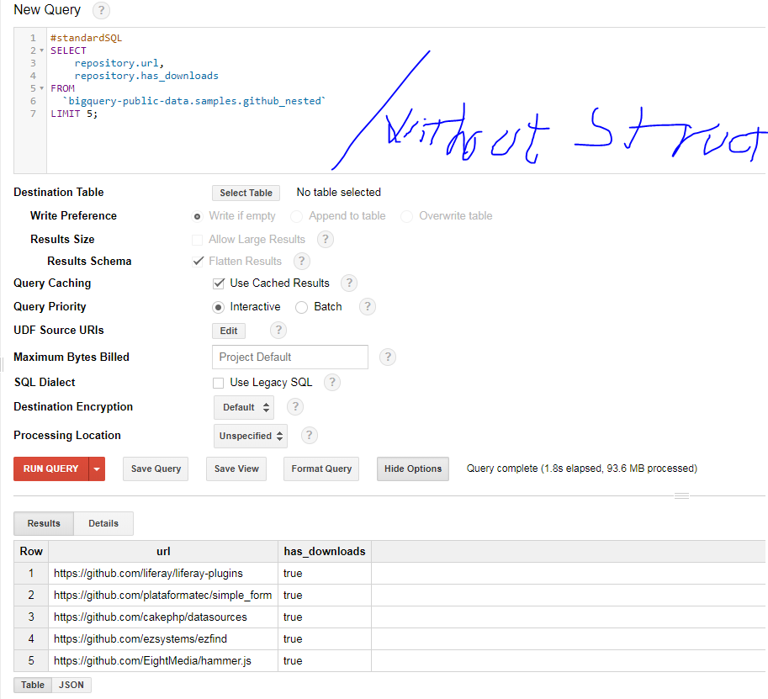

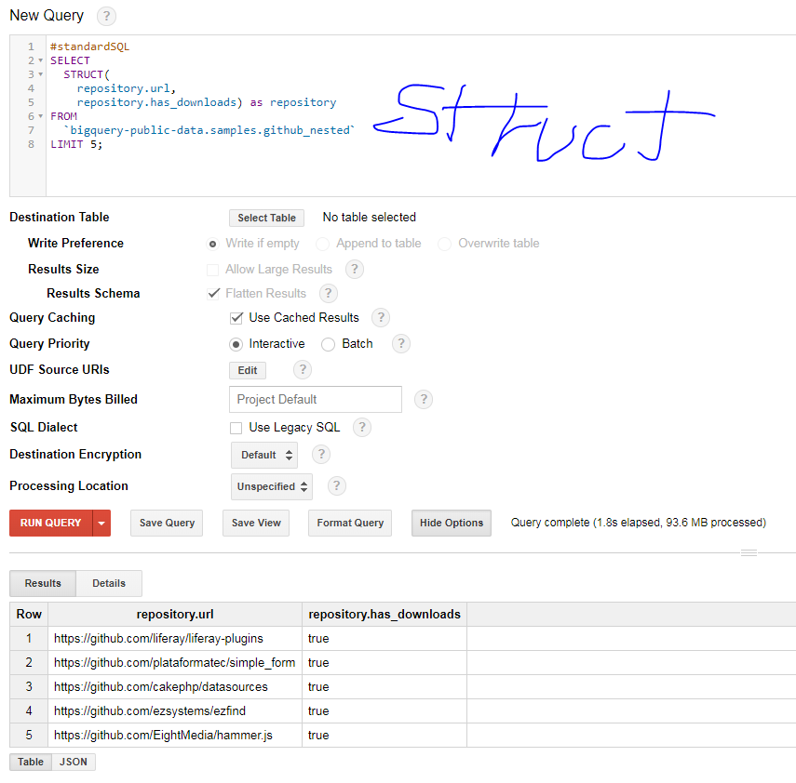

### Removing repetition with FLATTEN

### 